Butler/Indy Runners Bulldog Jog 15k Course
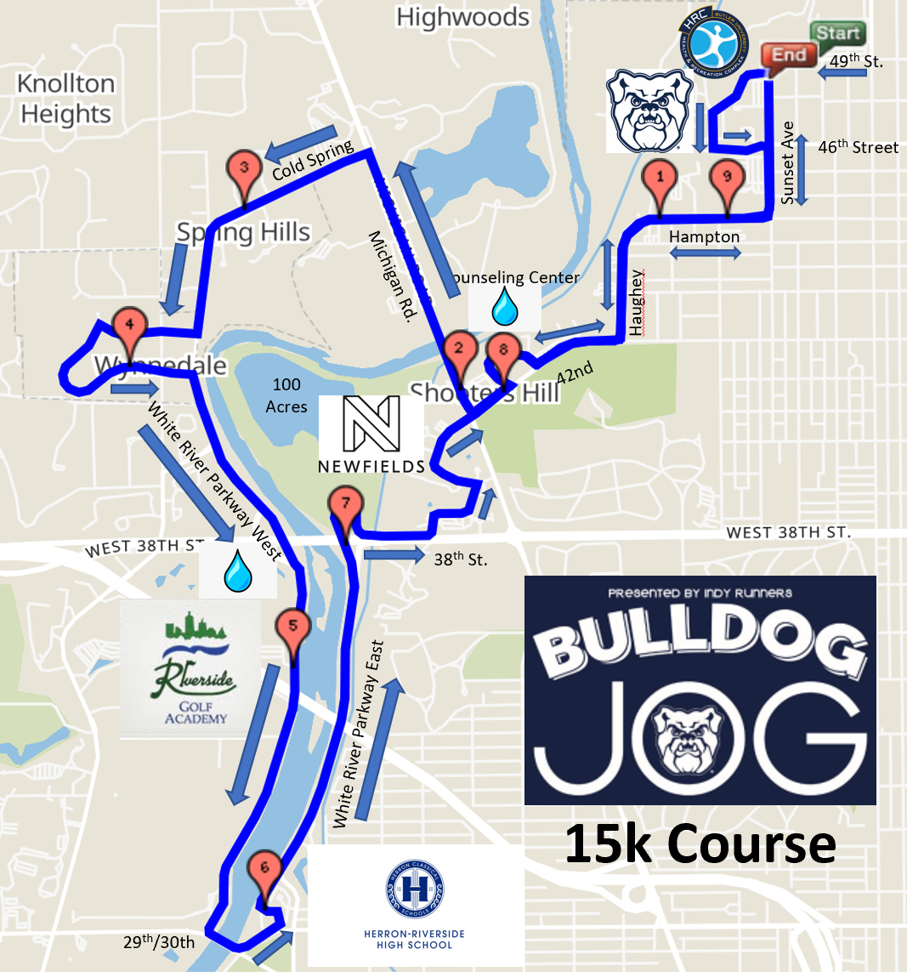
Start: 49th Street in front of Hinkle Fieldhouse Gate 4
Finish: Sunset Avenue in front of Chatham Tap
Aid Station #1/#3: South Campus Counseling Center – Mile 1.8 and Mile 8.1
Aid Station #2: White River Parkway Walking Path at 38th Street Overpass – Mile 4.7
Butler/Indy Runners Bulldog Jog 5k Course
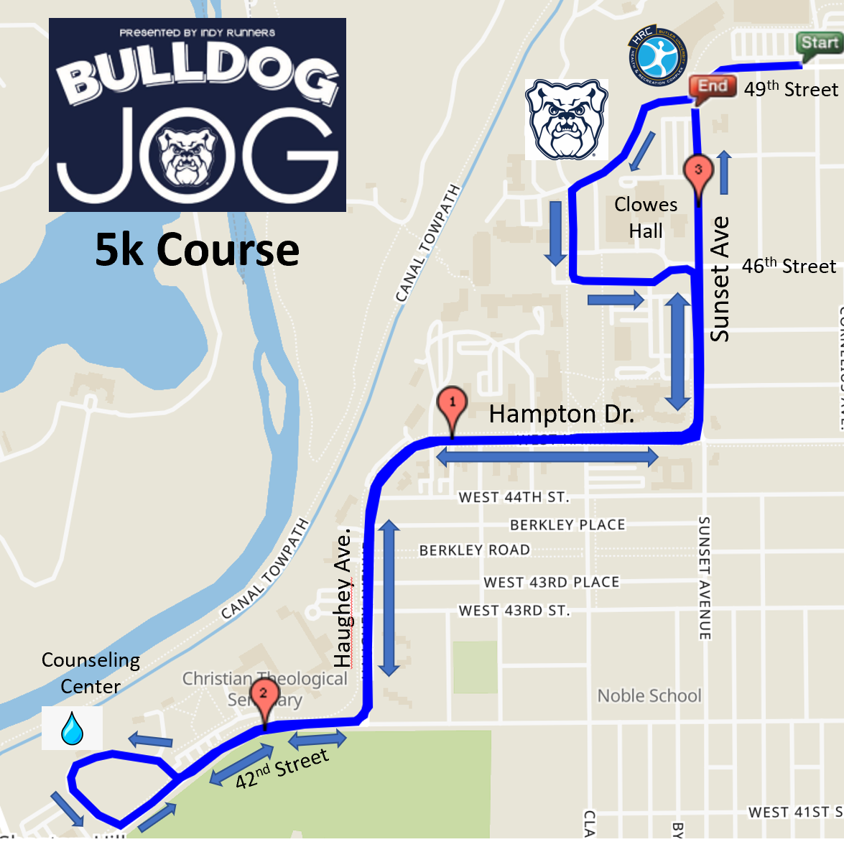

Start: 49th Street in front of Hinkle Fieldhouse Gate 4
Finish: Sunset Avenue in front of Chatham Tap
Aid Station: South Campus Counseling Center – Mile 1.8

