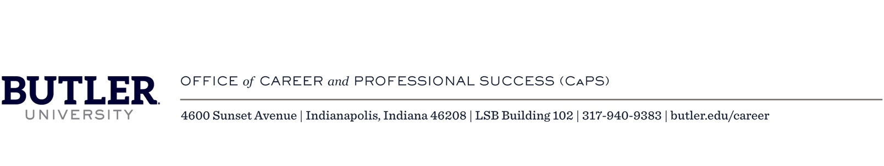

Employer and Recruiter Opportunities at Butler University

Describing Butler with Numbers
The following is a list of numerical data about Butler:
- 6 colleges
- 5,000+ total enrollment
- 15.3% multicultural and international students
- 48% of all Butler students come from the top 10% of their class
- 5 miles from downtown Indianapolis

What Others Say About Us
The following is a list of honors bestowed upon Butler by the U.S. News and World Report in 2018:
- Most Innovative School in the Midwest
- Ranked #2 College in the Midwest
- Ranked among the nation’s finest in:
  - First-year student experience
  - Internships
  - Study abroad
  - Undergraduate research and creative projects

The Butler Way
For each of the past several years, 97 percent of our graduates were employed, attending graduate school, or in gap-year/service programs within six months of graduation. Data is collected up to that six-month mark post-graduation, from sources including students, employers, faculty, staff, parents, and online.

Where We Come In
Career and Professional Success (CaPS) serves Butler students and alumni for life. In addition to career advising and student programming, we operate as the gateway for employers and recruiters to build relationships on our campus. We create opportunities for students, alumni, and recruiters to connect to support career development and the need for strong talent in the 21st century workforce.

Butler Students Are Gaining Valuable Experiences On Campus and Off
The following is a list reporting the percentages of Butler students who complete various types of experiences:
- 80% complete at least one internship
- 41% work on campus
- 94% are involved in campus activities
- 41% study abroad

Experiential Learning is a Key Part of Who We Are as a University
The following is a list of the approximate number of primary majors in each of Butler’s six colleges: Business, Communication, Education, Fine Arts, Liberal Arts and Sciences, and Pharmacy and Health Sciences.

College of Communication (CCOM)
- 450 undergraduates
- Many majors require a credit-bearing internship.
- Visit the CCOM website

College of Education (COE)
- 300 undergraduates
- All majors require two student teaching experiences.
- Visit the COE website

College of Liberal Arts and Sciences (LAS)
- 1,400 undergraduates
- Internship requirements vary per department.
- Visit the LAS website

College of Pharmacy and Health Sciences (COPHS)
- 900 students
- Most majors require rotations and/or an internship.
- Visit the COPHS website

Jordan College of the Arts (JCA)
- 350 students
- All majors require completion of career-related activities.
- Visit the JCA website

Lacy School of Business (LSB)
- 1,000 undergraduates
- All majors require two internships, and students follow a four-year Blueprint program.
- Students also have a career mentor for their four years.
- Visit the LSB website
Butler also offers several graduate programs and graduate non-degree certificates and licensures. Many emphasize experiential learning in their curriculum.

Off-Campus Opportunities
Many organizations offer off-campus engagement opportunities to continue to build their brand and connect with students. The following is a list of activities that our office has coordinated:
- Site visits
- Job shadowing opportunities
- Informational interviews
- Open houses
Please contact our office directly to discuss a personalized approach for your interests and goals.

Sponsorship Opportunities
Sponsorship increases brand recognition and awareness on campus. CaPS and Butler University offer a variety of event and programming sponsorship opportunities to showcase your organization to Butler students. If you are interested in sponsoring an event, please reach out directly to our office to discuss these options. We will work with you to create a personalized sponsorship plan that supports your brand and campus goals.

###

